**World Quant University**

**Professor: Ivan Blanco**

**Alpha Design I**

Nikolas Lippmann Pareschi - [nikolaslippmann@gmail.com](mailto:nikolaslippmann@gmail.com)

**Mini Project: Unit 5**

1. Write a Python program to download the historical data of Dow Jones Industrial Average (DJIA) over the last 15 years.

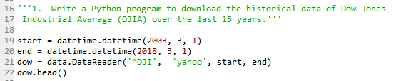

1. Construct a simple trading system that goes long when DJIA closes above its 20 Day Exponential Moving Average of Close Prices (20 DEMA) and closes in position and goes short when prices close below the 20 DEMA.

Code:

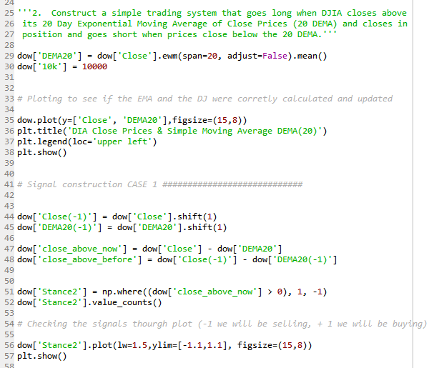

Results:

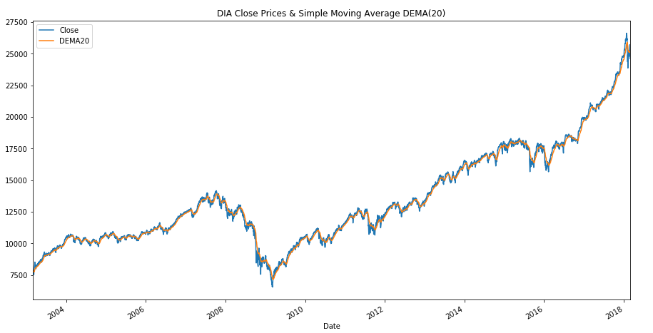

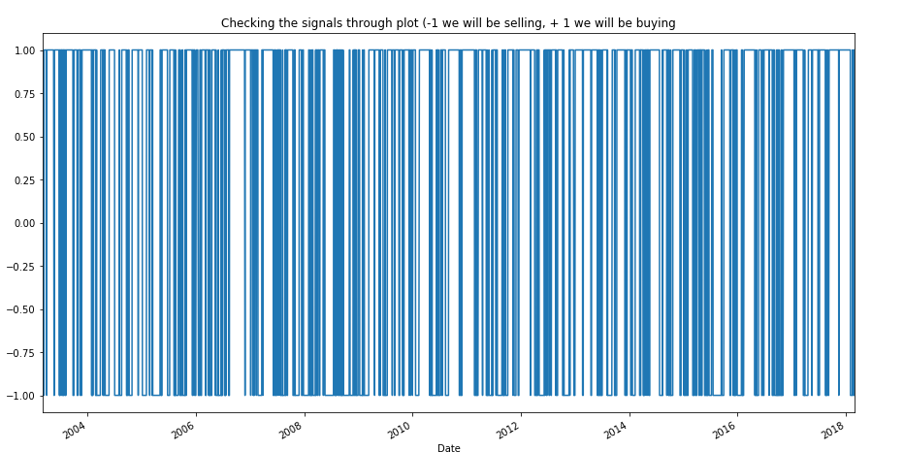

1. Exit from Trades are made by stop Market orders at the price of the 20 DEMA. Start with 10,000$ and always invest 1,000$ in every single trade

**Case 1:** Consider frictionless trading

* + 1. Consider that you are able to enter into trades exactly at the close price of the day on which the trend starts
    2. Consider ideal fills exactly on entry and stop loss exits on the 20DEMA.
    3. No Slippage or brokerage or commissions to be taken into account – consider you are trading for free!
    4. Plot the return profile of such a trading system.

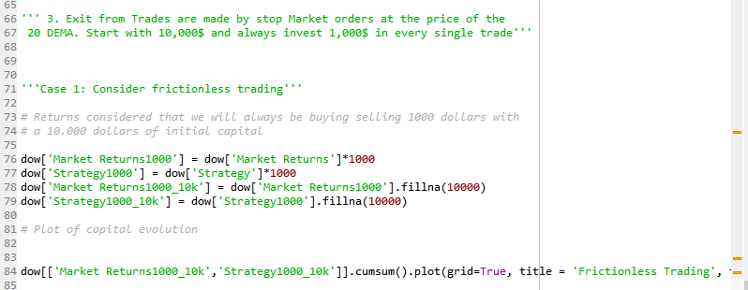

Results:

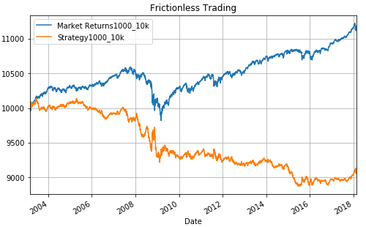

**Case 2:**Consider Real Trading

* + 1. **Gaps**: Enter trades at Market Open the next day through Stop Limit Orders – this is the way traders have to do things in real life (hence exposed to opening gaps)
    2. **Brokerage & Commissions:** Check the Interactive brokers site and decide on a Brokerage ratio to use for your trades
    3. **Slippage:** Use the model generated in Unit 5 Assignment to consider slippages on each and every trade.
    4. Graphically represent the return profile of this strategy

Code:

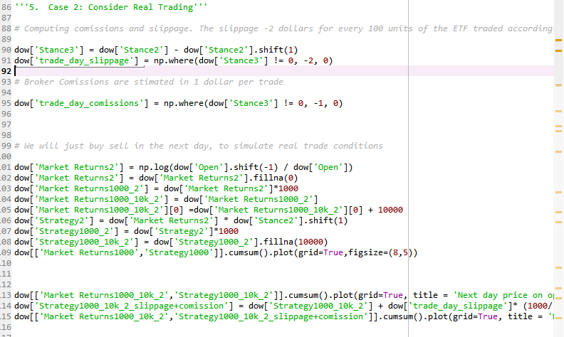

I considered that 1 dollar will be paid in commission in each trade. For slippage I considered the results in assignment 5. We will pay 0.02 of slippagge per 1 units of Dow Jones negotiated. As the common order is 100 we will be paying 2 dollars per 100*Dow Jones ETF price. As we only buy or sell 1000 dollars we computed the mean of Dow Jones price, considering the firs trade in 2003 and the last trade in 2018 and then we did the ratio.

The trade is done in the next day from the signal on the opening price. The first graph is without commissions and slippage. The second one with commissions and slippage:

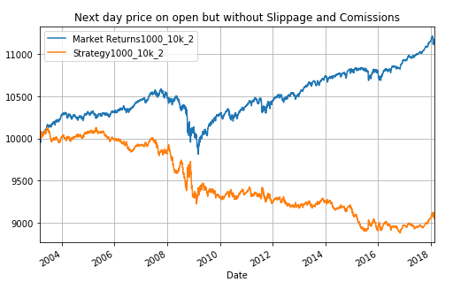

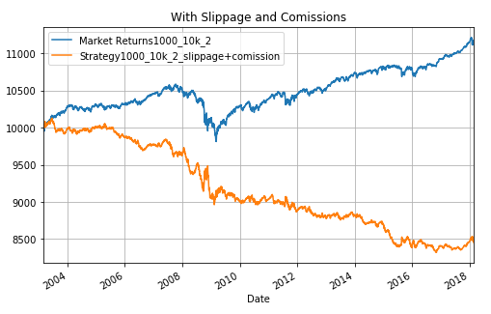

1. Compare the Risk-Return Profiles of both the systems and draw inferences

The returns of the strategy were negative. When we consider that we can only trade in next day on the opening the returns were worse. The slippage and commissions made the strategy even worse as we can see from our graphs. But most of the loss came from the strategy, not from commissions and slippage.